Bridgepoint Parts Catalog

Section XXI: Vacuum Motors and Blowers Page 1

PP41-905012

Blower – Sutorbilt 3MP
Prochem: Cub, CubXL, Trailblazer, 150, 100A, Oil Fired TM, and Blazer
Bridgepoint: System IV & Saber

PHY111-011

Blower – Sutorbilt 3LL

Twin Shaft
Hydramaster: Bobcat 3.5,
Hydracat 3.5, Aquacat 3.5 and Aquacat 3.9

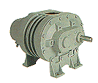
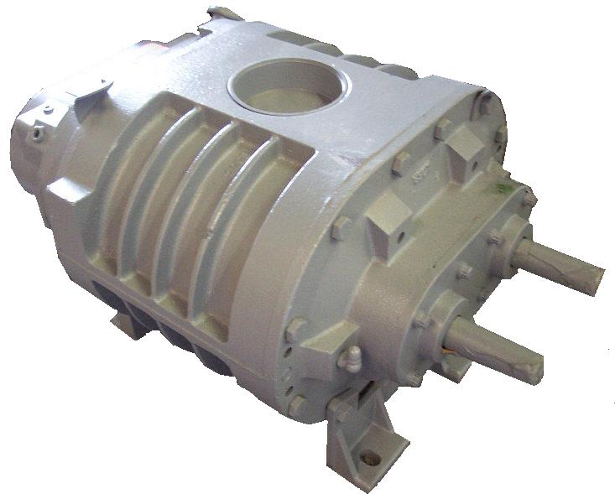

PP41-905021

Blower – Sutorbilt 4ML
Prochem: Bear, Bruin, Bruin II, Legend SE, Legend XL, Legend GT, 800A, & Performer
Sapphire: Champ Bridgepoint: Lancer & Lancer II

PHY111-003

Blower – Sutorbilt 4ML

Twin Shaft

Hydramaster: Hydracat 4.0 & CDS 4.0

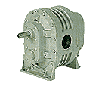

PP41-905024

Blower – Sutorbilt 3LP
Prochem: Legend, Blazer Plus,
Blazer XL & Power Vac Sapphire: 270SS Bridgepoint: Saber 2000

PHY111-006

Blower – Sutorbilt 4LL

Twin Shaft
Hydramaster: Hydracat 4.5 &
CDS 4.5

PHY111-020

Blower – Roots 33

Twin Shaft
Hydramaster: Spitfire 3.2
Bridgepoint: Dagger

PP41-905026

Blower – Sutorbilt 4LL
Prochem: Performer 405, PTO &
Power Vac II

PP41-905047

Blower – Sutorbilt 5L
Prochem: Performer 805

PHY111-021

Blower – Roots 36

Hydramaster: Crossfire 3.7 & Profire 3.7

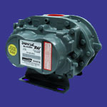

PHY111-145

Blower – Tuthill 4005X
Hydramaster: Boxxer 421
(CDS 4.6 & Maxx 450D since November 2001)

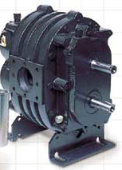

PHY111-022

Blower – Roots 45
Hydramaster: CDS 4.2, Crossfire ` 4.2, Crossfire 4.4 & Spitfire 4.0
(CDS 4.6 & Maxx 450D up until October 2001)

PHY111-147

Blower – Tuthill 4007X

Hydramaster:
(CDS 4.8 & Maxx 470D since November 2001)

PHY111-023

Blower – Roots 47

Hydramaster: CDS 4.7
(CDS 4.8 & Maxx 470D up until October 2001)
Bridgepoint: Javelin

PP140611

Blower – Sutorbilt TI408
Prochem: Apex, Everest &
Everest HP
Sapphire: Bluewave & 454SS
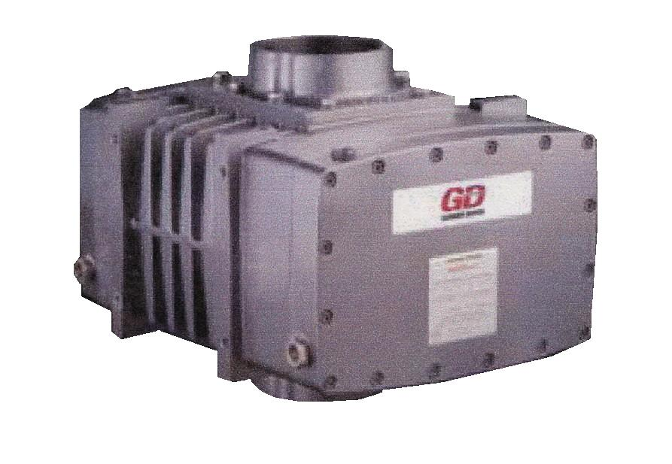

PHY111-167

Blower – Tuthill MD4007
Hydramaster: Boxxer 427

PP140618

Blower – Sutorbilt TI406
Prochem: Peak & Peak GTX
Sapphire: Cobalt & 370SS

Bridgepoint Parts Catalog

Section XXI: Vacuum Motors and Blowers Page 2

PWM-A001W

Blower – Roots 45 Whispair
White Magic: Pro1000, Pro1600
Pro 2000 (Qty 2) & Commander
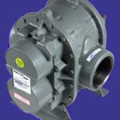

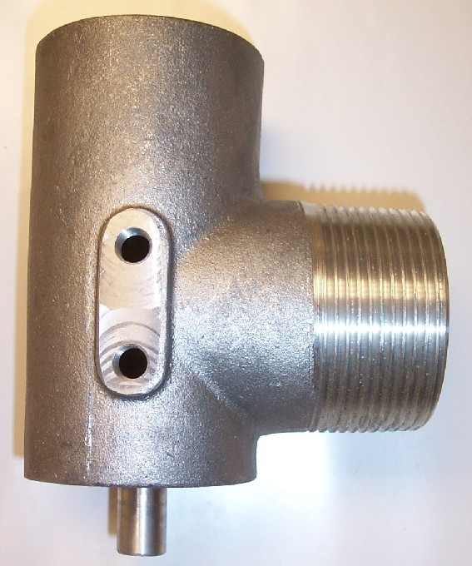

PWM-A004

Blower – Roots 59

White Magic: Pro1900

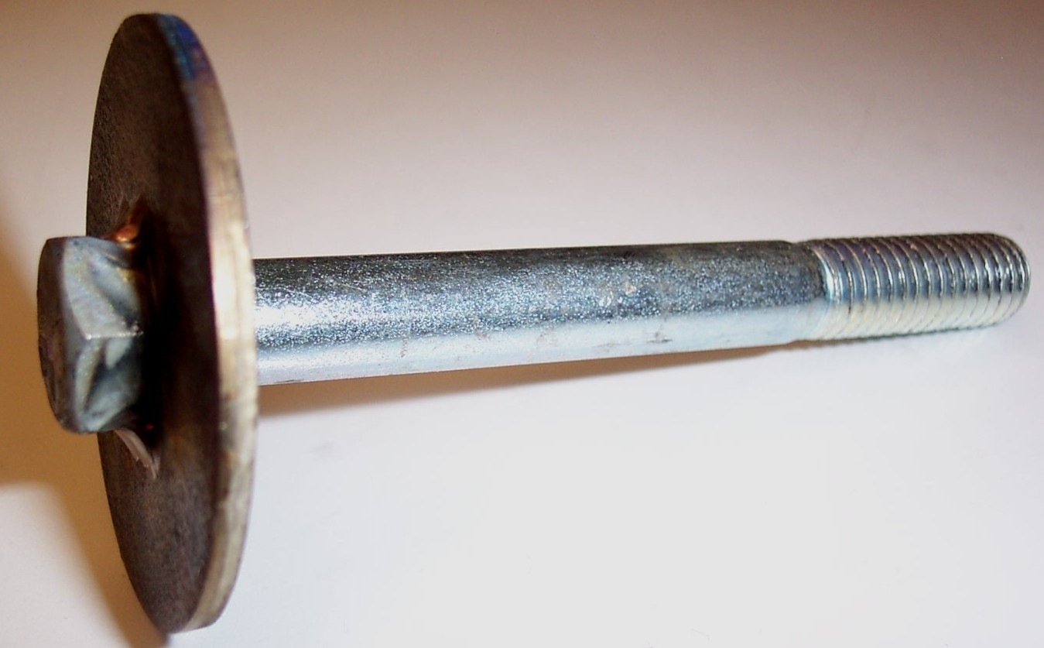

PWM-M502W

Blower – Roots 56 Whispair
White Magic: Pro1200 & Pro1800

PP56-501614

Stem - Vac Relief Valve

Prochem: Cub, CubXL, 100A, 150,
Oil fired TM, Blazer and Trailblazer
Bridgepoint: System IV & Saber

PP52-501567

Vac Relief Valve Body

Vac Inlet Elbow

Prochem: Cub, CubXL, 100A, 150,
Oil fired TM, Blazer and Trailblazer
Bridgepoint: System IV & Saber

PP43-807073

Diaphragm - Vac Relief Valve
Prochem: Cub, CubXL, 100A, 150,
Oil fired TM, Blazer, Blazer XL and Trailblazer
Bridgepoint: System IV & Saber

PP52-501573

Vac Relief Valve Body

Vac Inlet Elbow
Prochem: 800A, Performer, Bruin,
Bruin II, Bear, Blazer Plus,
Power Vac, Legend, Legend SE & Legend XL
Bridgepoint: Lancer, Lancer II & Saber 2000

PP52-501684

Vac Relief Valve Body

Vac Inlet Elbow
Prochem: Apex, Everest,
Everest HP, Performer 405, PTO
& Power Vac II

PP56-501615

Stem - Vac Relief Valve
Prochem: 800A, Performer, Bruin, Bruin II, Bear, Blazer Plus,
Blazer XL, Power Vac, Legend, Legend SE & Legend XL
Bridgepoint: Lancer, Lancer II & Saber 2000

PP43-807018

Diaphragm - Vac Relief Valve
Prochem: 800A, Performer, Bruin, Bruin II, Bear, Blazer Plus, Power Vac, Legend, Legend SE, Blazer XL & Legend XL
Bridgepoint: Lancer, Lancer II & Saber 2000

PP04-000091

Spring - Vac Relief Valve

Prochem: All truckmounts
Bridgepoint: Lancer, Lancer II, System IV, Saber & Saber 2000

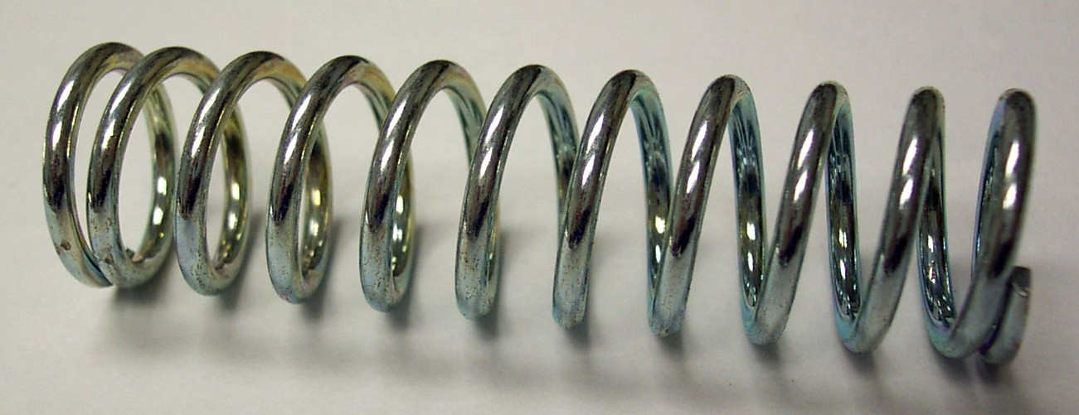

PP56-501994

Stem - Vac Relief Valve
Prochem: Apex, Everest,
Everest HP, Performer 405, PTO
& Power Vac II

PP43-807106

Diaphragm - Vac Relief Valve
Prochem: Apex, Everest,
Everest HP, Performer 405, PTO
& Power Vac II

PHY057-062

Gasket – CDS 4.7 Blower
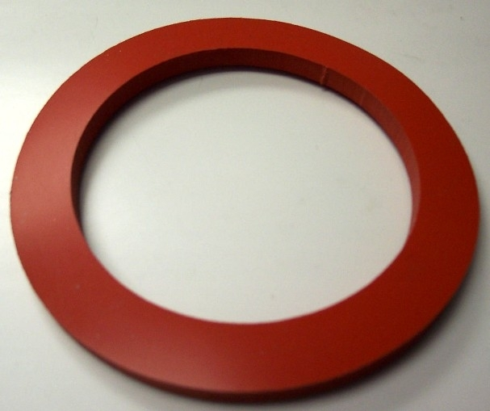

PHY078-043

Kit Vacuum Relief Valve

Hydramaster: Aquacats, Bobcats, Hydracats, Crossfires, Spitfires, Profires, CDS 4.0, CDS 4.2, CDS 4.5 & CDS 4.7. Bridgepoint: Dagger
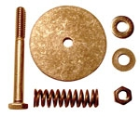

PHY057-056

Gasket – CDS 4.2 Blower

Bridgepoint Parts Catalog

Section XXI: Vacuum Motors and Blowers Page 3

AV08

Vac Motor 5.7” 2 Stage
ULV Fogger Fan
Hydro-Force: PureMist
Dri-Eaz: MacroMist II
Unsmoke: Blastmaster GS

AV06

Vac Motor 4.8” 2 Stage
Hydro- Force: Power X Spot (MA50) & Power Spot (MA40)

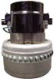
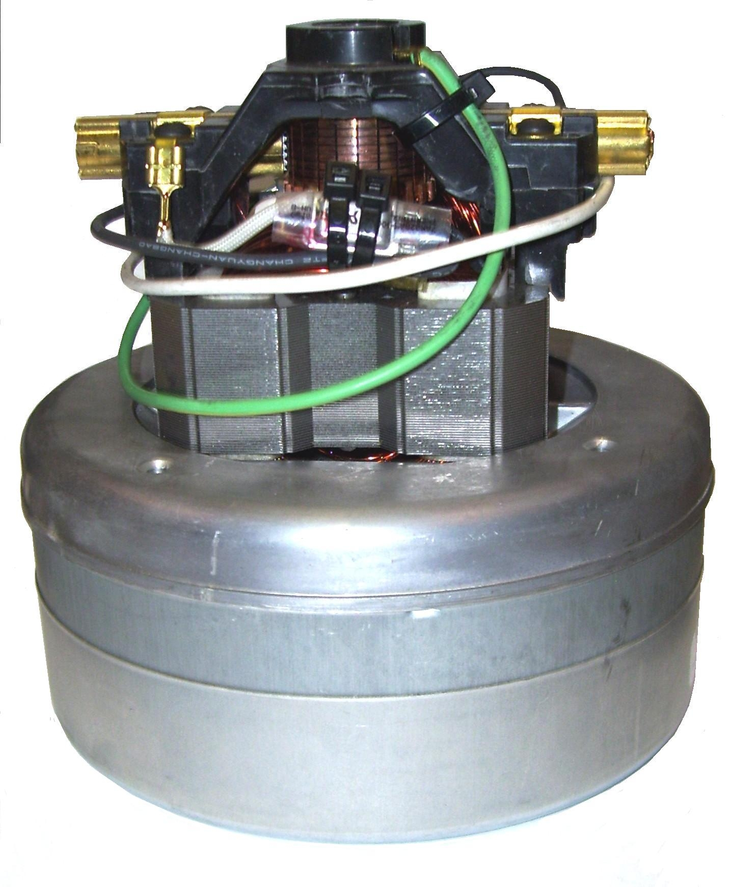

AV12

Vac Motor HP 5.7” 2 Stage

High Amp 115vac

with Vac Hose Flange
FX88 & FX88HP

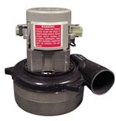

AV010

Vac Motor 5.7” 2 Stage – 115vac
Fits most portable extractors

AV012 – 230vac model
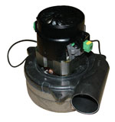

AV13

Vac Motor HP 5.7” 2 Stage

Low Amp 115vac

with Vac Hose Flange
FX88 & FX88HP

AV14

Vac Motor 5.7” 3 Stage – 115vac
Fits most portable extractors

AV16 – 230vac model
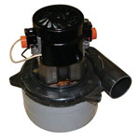

AV23

Vac Motor 5.7” 3 Stage – 115vac

High Performance
Phoenix: Hydro-X Vac Pac
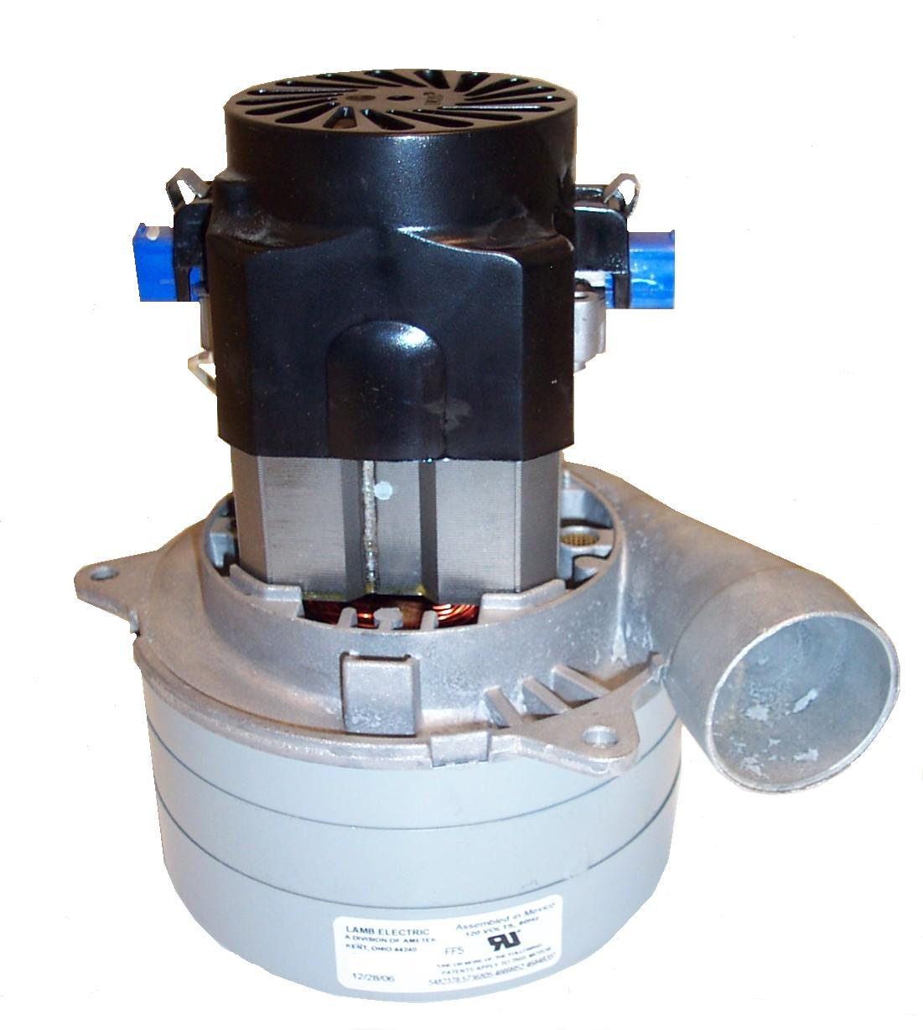

PSD021

Vac Motor Assembly
Steamin Demon

AV20

Vac Motor 8.4” 2 Stage – 115vac
Nautilus: MX500-HP

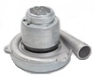

AV18

Vac Motor 7.2” 3 Stage
Larger Size Vac Motor
Fits many portable extractors
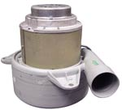

PA010

Gasket Vac Motor 5.7”

5/8” Thick – One side Adhesive
Olympus Portables
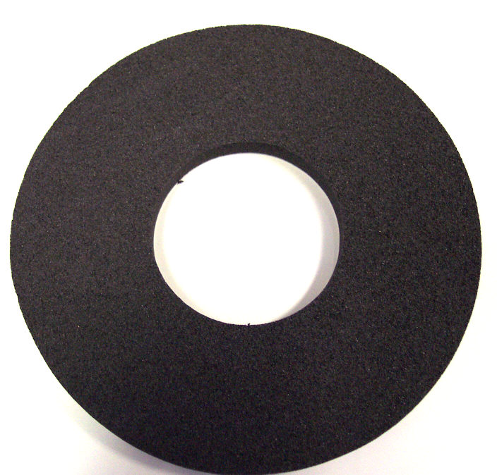

PA010B

Gasket Vac Motor 8.4”

5/8” Thick – One side Adhesive
Nautilus MX500-HP

PA010A

Gasket Vac Motor 5.7”

5/8” Thick – One side Adhesive
Nautilus Portables

PP43-807110

Gasket – Vac Motor 5.7”

3/8” Thick – One side Adhesive
MyTee Part # G004

PMA740043

Flange 2” – Vac Motor Intake

Truck Force, FX88 & FX88HP

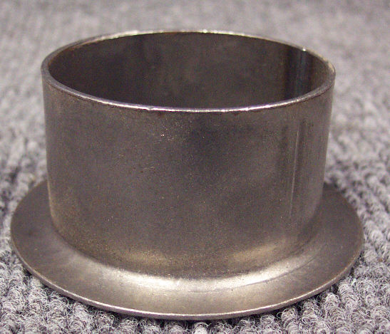

PP43-807526

Gasket Vac Motor 4.8”

1/4” Thick – One side Adhesive
Power Spot (MA40) & Spot Pro

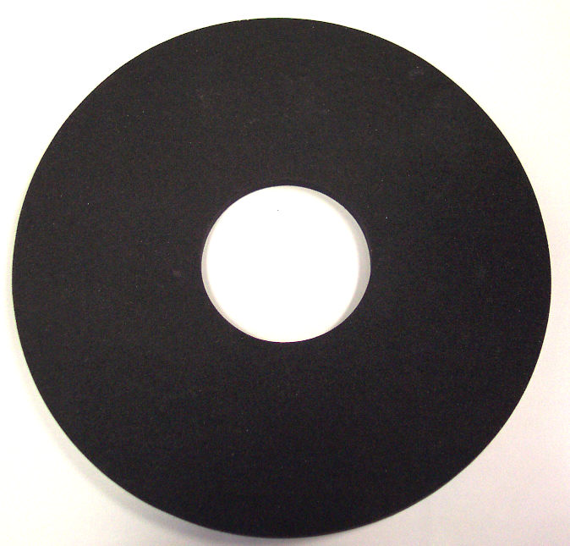

PMA740044

Adhesive Seal Strip

for 2” Flange – Vac Motor
Truck Force, FX88 & FX88HP

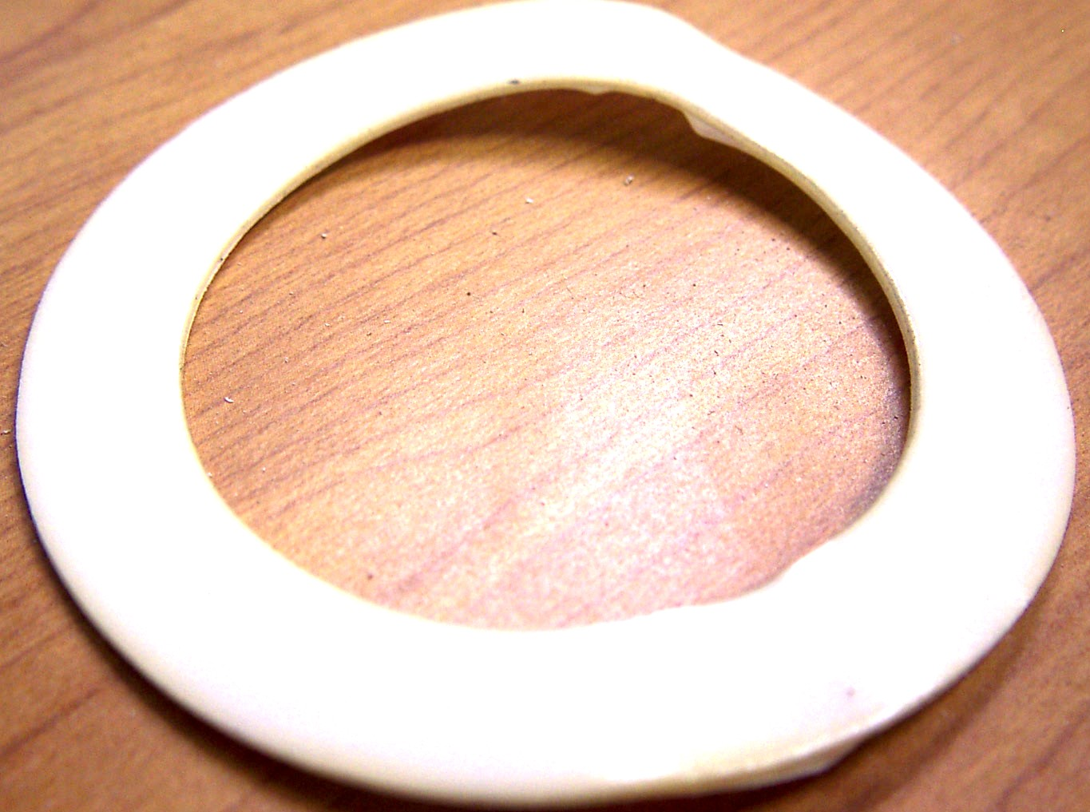

NM5050

Vac Hose 1-1/2”

Wire Reinforced – per foot
Vac Motor Connections

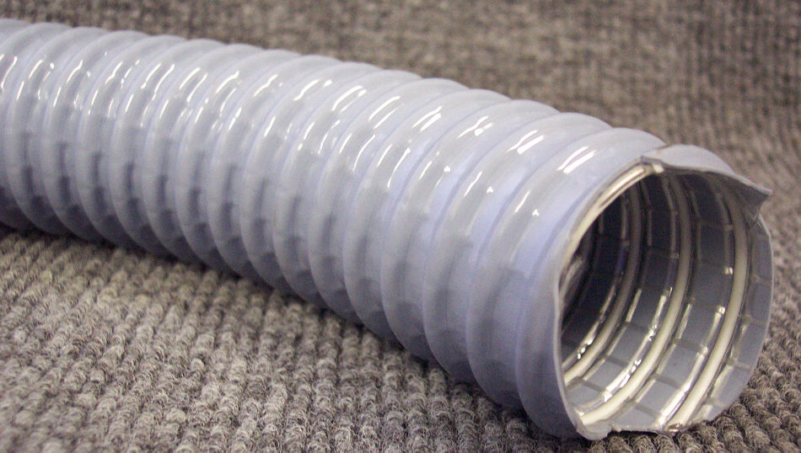

PMP735

Manifold Vac Mount – Plastic
EX Portable Extractors

NM5726

Vac Hose 2”

Wire Reinforced – per inch
Vac Motor Connections

NM5018

Vac Ducting 3” x 18”
Olympus Portables

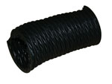

NM5015

Grate – Vac Exhaust 4”
Olympus Portables

PAM60-3776-4

Cover Vac Motor – Black Plastic

AV14 / AV16 / AV010 / AV012/ AV06
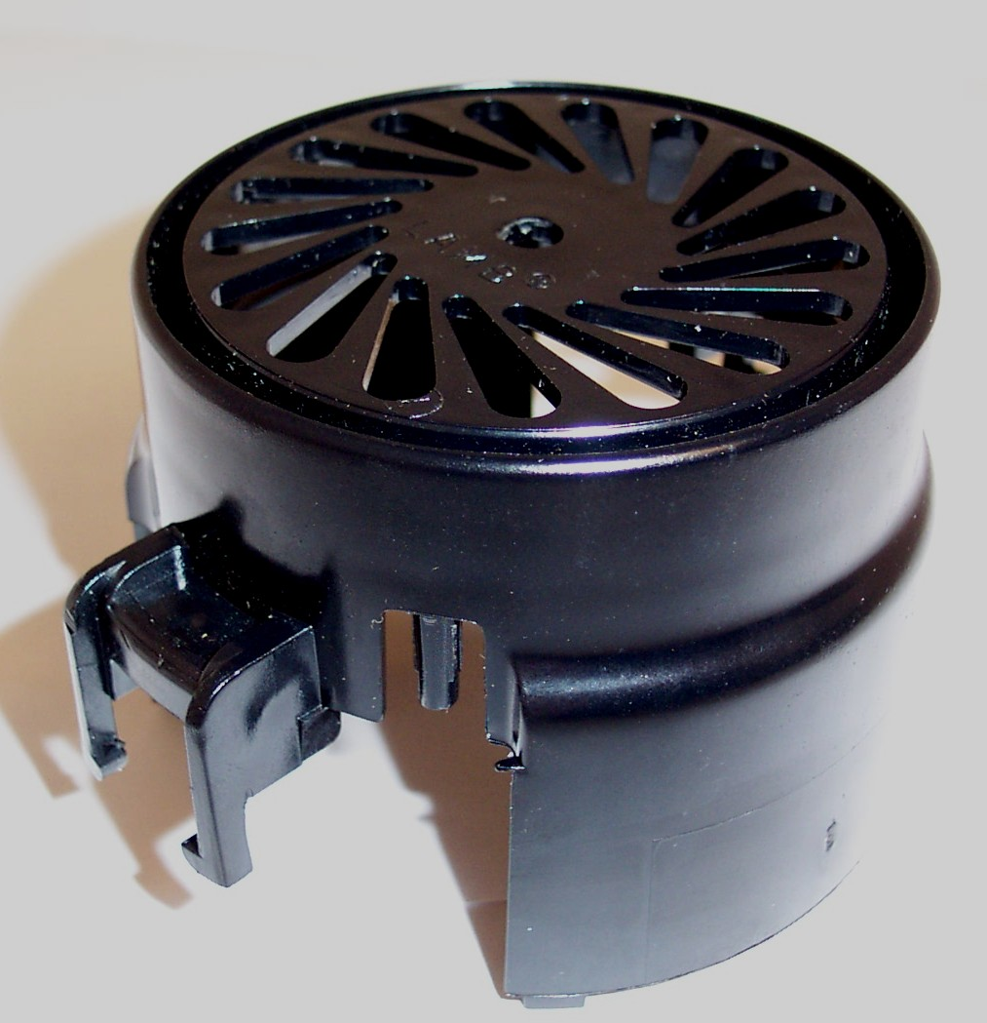
Bridgepoint Parts Catalog

Section XXI: Vacuum Motors and Blowers Page 4

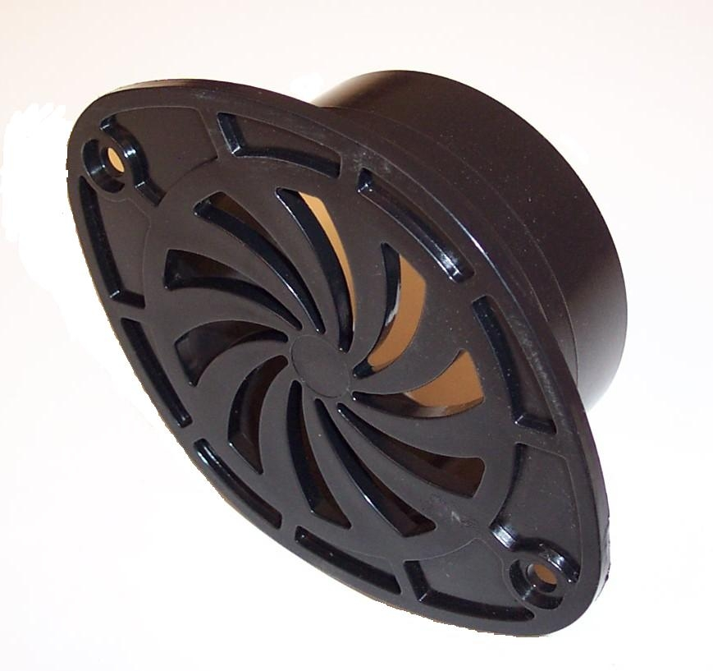

PXL90-3739

Cover Vac Motor – White Plastic

AV14 / AV16 / AV010 / AV012
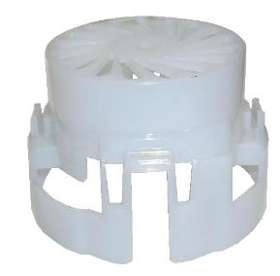

NM5706

Manifold Vac Mount – Plastic
Nautilus Extractors

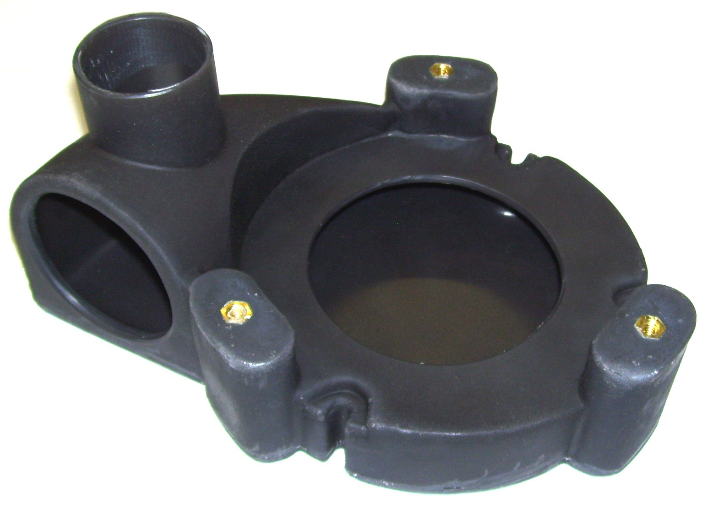

NM5699

Manifold 8.4” Vac Mount

Plastic – Nautilus MX500-HP

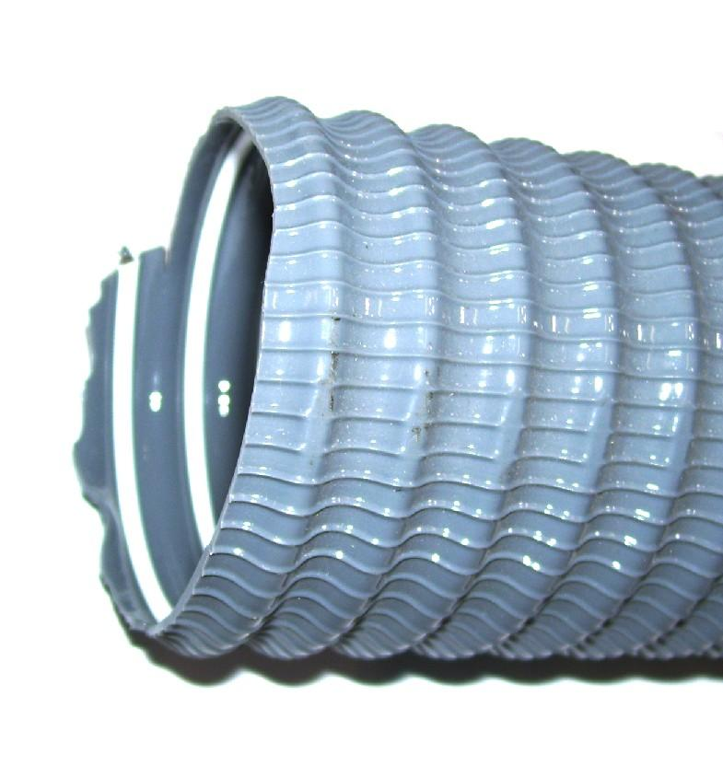

NM5728

Gate Valve 2” slip w/ Gatekeeper

PVC – Black
Gatekeeper: NM5728B
Gasket: NM5728A

